POLYTECHNICS MAURITIUS
Higher National Diploma in Internet of Things (IoT) and Big Data Analytics (BDA)
Cohort IoT 7

MATLAB ASSIGNMENT
4G & 5G CELLULAR ARCHITECTURE
Building a Mobile Signal Simulator and Designing a Mobile Network
LEVEL  Diploma | SOFTWARE  MATLAB | DURATION  2 Weeks | TOTAL MARKS  100

Field | Details
Prepared by | Reelesh Ganesh Bhoyrub
Team Member | Theerouven Chinnecunnen
Team Member | Aldo Nullacoottee
Programme | HND in Internet of Things (IoT) and Big Data Analytics (BDA)
Cohort | IoT 7
Module / Software | MATLAB — 4G & 5G Cellular Architecture
Date | July 2026

Table of Contents
Table of Contents 2
1. Introduction 3
1.1 Scenario 3
1.2 Objectives and Learning Outcomes 3
1.3 Tools and Software Used 3
1.4 Report Structure 3
2. Part A — Network Visualisation Using MATLAB 4
2.1 A1 — Single Cellular Cell 4
MATLAB Code 4
Explanation 4
2.2 A2 — Seven-Cell Cluster and Frequency Reuse 6
MATLAB Code 6
Explanation 6
2.3 A3 — Handover Illustration 7
MATLAB Code 7
Explanation 7
3. Part B — Mobile Signal Simulator 8
Program Structure 8
3.1 B1 — Main Menu and Network Selection 9
3.2 B2 — Signal Strength Calculator 9
3.3 B3 — Throughput Calculator 10
3.4 B4 — User Capacity Check 10
3.5 B5 — Network Summary 12
4. Part C — Graphs and Performance Analysis 13
4.1 C1 — Signal Strength vs Distance 13
4.2 C2 — Throughput Comparison 13
4.3 C3 — User Capacity 14
5. Assumptions and Design Decisions 15
6. Remaining Work 16
6.1 Part D — Discussion (15 marks) 16
6.2 Part E — Design Your Own Network (20 marks) 16
7. Conclusion 17
8. Marking Scheme Reference 18

1. Introduction

1.1 Scenario
A telecom operator wants to compare its existing 4G LTE network with a proposed 5G NR network. In this assignment, our team takes on the role of junior engineers asked to build a MATLAB application that visualises cellular network concepts, simulates network performance, and allows the design of a custom mobile network.

1.2 Objectives and Learning Outcomes
The assignment was designed to help us achieve the following learning outcomes:
- Explain the concepts of cell, cluster, frequency reuse, and handover using MATLAB diagrams.
- Build a menu-driven Mobile Signal Simulator.
- Calculate and compare throughput, signal strength, latency, and capacity between 4G and 5G.
- Visualise results using graphs (line plots, bar charts, and pie charts).
- Design and evaluate a custom mobile network using MATLAB.

1.3 Tools and Software Used
- MATLAB Online (accessed through MATLAB Drive)
- MATLAB scripting: variables, vectors, loops (for/while), conditional statements (if/switch), custom functions, and plotting commands

1.4 Report Structure
This report is organised to follow the structure of the assignment brief. Section 2 covers Part A (Network Visualisation), Section 3 covers Part B (the Mobile Signal Simulator), and Section 4 covers Part C (Graphs and Performance Analysis). Each subsection explains the concept being demonstrated, shows the MATLAB code used, and presents the actual output produced when the code was run. Section 5 lists the assumptions made while completing the work, and Section 6 outlines the parts of the assignment that are still in progress. The report closes with a conclusion and a summary of the official marking scheme.

2. Part A — Network Visualisation Using MATLAB
Part A focuses on drawing static diagrams that explain the basic building blocks of a cellular network: a single cell, a cluster of cells, and the handover process between two adjacent cells. Hexagon shapes are used throughout because they tile a map without gaps or overlaps, which is why real cellular networks are modelled using hexagonal cells.
Every diagram in this section was drawn using basic MATLAB plotting commands (plot, text) combined with simple trigonometry (cos and sin) to calculate the corner points of each hexagon.

2.1 A1 — Single Cellular Cell
This is the most basic diagram in the assignment: one hexagonal cell with a Base Station (BS) at the centre and one User Equipment (UE) placed inside the cell boundary. A dashed red line represents the radius (R), the distance between the BS and the UE.

MATLAB Code
R = 5;
theta = linspace(0, 2*pi, 7) + pi/6;
hexX = R * cos(theta);
hexY = R * sin(theta);
plot(hexX, hexY, 'b-', 'LineWidth', 2); % draw hexagon

plot(0, 0, '^', 'MarkerFaceColor', 'r'); % Base Station
text(0, -0.7, 'BS', 'HorizontalAlignment', 'center');

ueX = 2.5; ueY = 1.5;
plot(ueX, ueY, 'o', 'MarkerFaceColor', 'g'); % User Equipment
plot([0 ueX], [0 ueY], 'r--', 'LineWidth', 1.5); % Radius (R)
Code Snippet 1: Drawing a single hexagonal cell with a Base Station, User Equipment, and radius line.
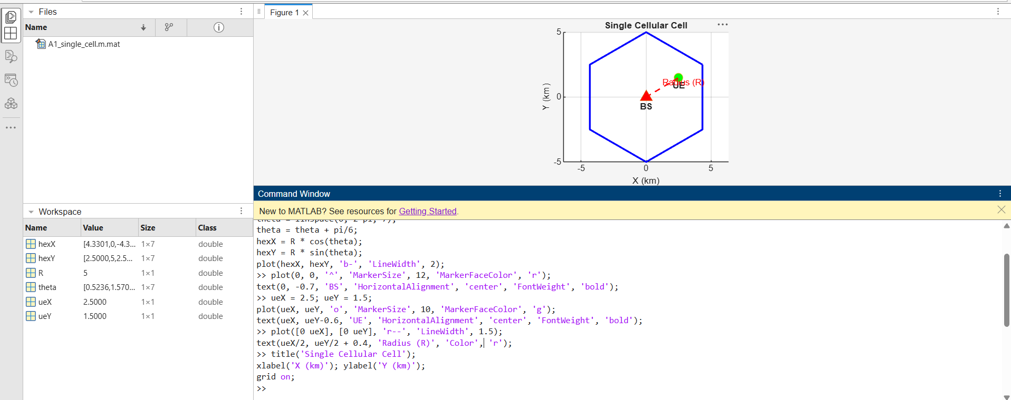
Figure 1: MATLAB output — single cellular cell showing Base Station (BS), User Equipment (UE), and radius (R)

Explanation
A cell is the geographic area covered by one Base Station. The BS is placed at the centre of the hexagon so that the signal can reach every point in the cell as evenly as possible, and so that the maximum distance any user can be from the BS is kept roughly the same in every direction. This balances coverage quality with the amount of interference caused to neighbouring cells.

2.2 A2 — Seven-Cell Cluster and Frequency Reuse
This diagram shows seven hexagonal cells arranged together in the classic honeycomb pattern used in cellular network planning: one centre cell surrounded by six neighbouring cells. Each cell is numbered 1 to 7 and has its own Base Station. Letters A, B and C are used underneath each cell number to show its frequency reuse group.

MATLAB Code
R = 3;
centerDist = R * sqrt(3);
angles = 0:60:300; % 6 directions, 60 degrees apart

centersX = [centerDist*cosd(angles), 0]; % 6 outer cells + 1 centre cell
centersY = [centerDist*sind(angles), 0];

cellNumbers = {'1','2','3','4','5','6','7'};
freqGroups = {'A','B','C','A','B','C','-'};

for i = 1:7
drawHexCell(centersX(i), centersY(i), R, cellNumbers{i}, freqGroups{i});
end
Code Snippet 2: Looping through 7 positions to draw a full cell cluster using a reusable function.
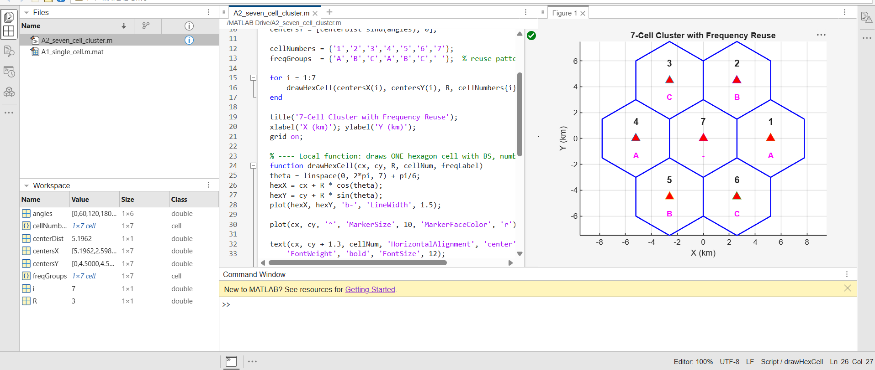
Figure 2: MATLAB output — seven-cell cluster showing cell numbering and frequency reuse groups (A, B, C)

Explanation
A cluster is a group of neighbouring cells that, together, use the entire set of available radio frequencies exactly once before the pattern repeats in the next cluster. Frequency reuse is essential because the radio spectrum available to an operator is limited. By reusing the same frequency in cells that are far enough apart (for example, cells 1 and 4, both labelled 'A'), the network can serve a much larger area and many more users than the spectrum would otherwise allow, without cells causing harmful interference to one another.

2.3 A3 — Handover Illustration
This diagram shows two adjacent cells, Cell A and Cell B, each with its own Base Station. A user's movement is represented as a dashed path starting inside Cell A and ending inside Cell B, with a clearly marked handover point at the cell boundary.

MATLAB Code
cellA_center = [0, 0];
cellB_center = [R*sqrt(3), 0];
drawHexCell(cellA_center(1), cellA_center(2), R, 'Cell A');
drawHexCell(cellB_center(1), cellB_center(2), R, 'Cell B');

userStart = [-2, 0.5]; userEnd = [4, -0.5];
handoverPoint = [cellA_center(1) + R*sqrt(3)/2, 0];

plot([userStart(1) userEnd(1)], [userStart(2) userEnd(2)], 'r--');
plot(handoverPoint(1), handoverPoint(2), 'kx', 'MarkerSize', 14, 'LineWidth', 3);
text(handoverPoint(1), handoverPoint(2)+0.5, 'Handover Point');
Code Snippet 3: Plotting two adjacent cells with a user path and a marked handover point.
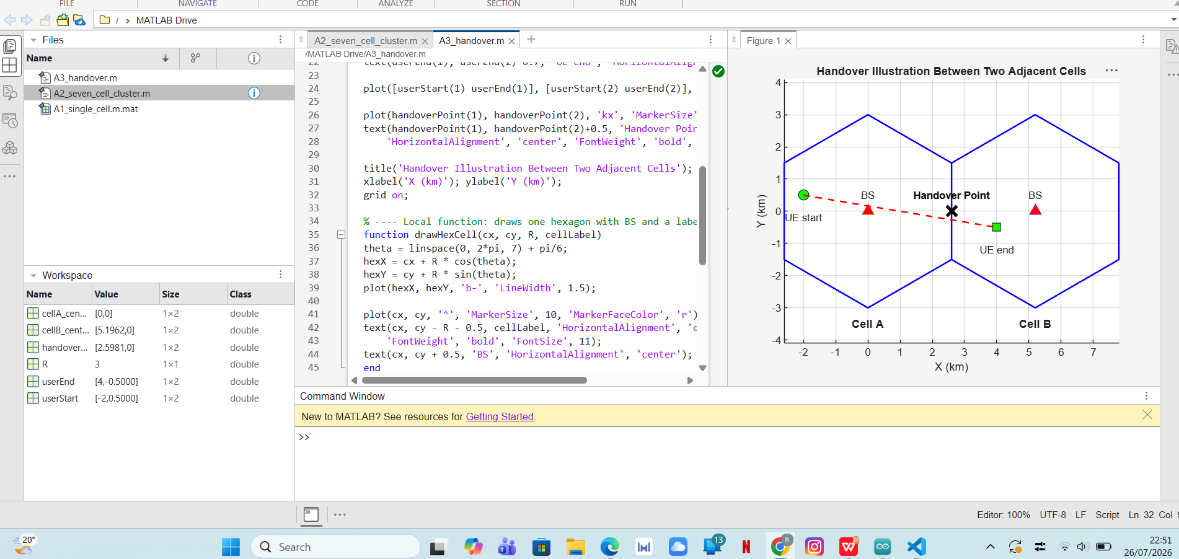
Figure 3: MATLAB output — handover illustration between two adjacent cells

Explanation
Handover is the process of transferring an active connection from one Base Station to another as a user moves out of the range of one cell and into the range of a neighbouring cell. It is necessary because, without handover, a user's call or data session would simply drop the moment they leave the coverage area of their current cell. If handover fails, the practical result for the user is a dropped call or a sudden loss of the mobile data connection, which is why it is one of the most critical processes in a mobile network.

3. Part B — Mobile Signal Simulator
Part B is a menu-driven MATLAB program (MobileSignalSimulator.m) that lets the user interact with the system through a simple text menu displayed in the Command Window. The user can select a network technology, calculate signal strength, calculate throughput, check user capacity, and view a summary of every result calculated so far. The program keeps showing the menu and accepting choices until the user selects Exit.

Program Structure
The overall program is built using a while loop that keeps the menu running, combined with a switch-case statement that decides what to do based on the number the user types. This structure is shown below:
keepRunning = true;
while keepRunning
disp('==== MOBILE SIGNAL SIMULATOR ====');
disp('1. Select Network Technology');
disp('2. Signal Strength Calculator');
disp('3. Throughput Calculator');
disp('4. User Capacity Check');
disp('5. Network Summary');
disp('6. Exit');
choice = input('Enter your choice: ');

switch choice
case 1 ... case 2 ... case 3 ...
case 4 ... case 5 ...
case 6
keepRunning = false; % stops the loop, exits the program
end
end
Code Snippet 4: The main menu loop that drives the entire Mobile Signal Simulator.

3.1 B1 — Main Menu and Network Selection
Option 1 of the menu lets the user choose between 4G LTE and 5G NR. The chosen technology is stored in a variable called selectedTech, which is then reused automatically by the other calculators later in the program, so the user does not need to re-enter it every time.
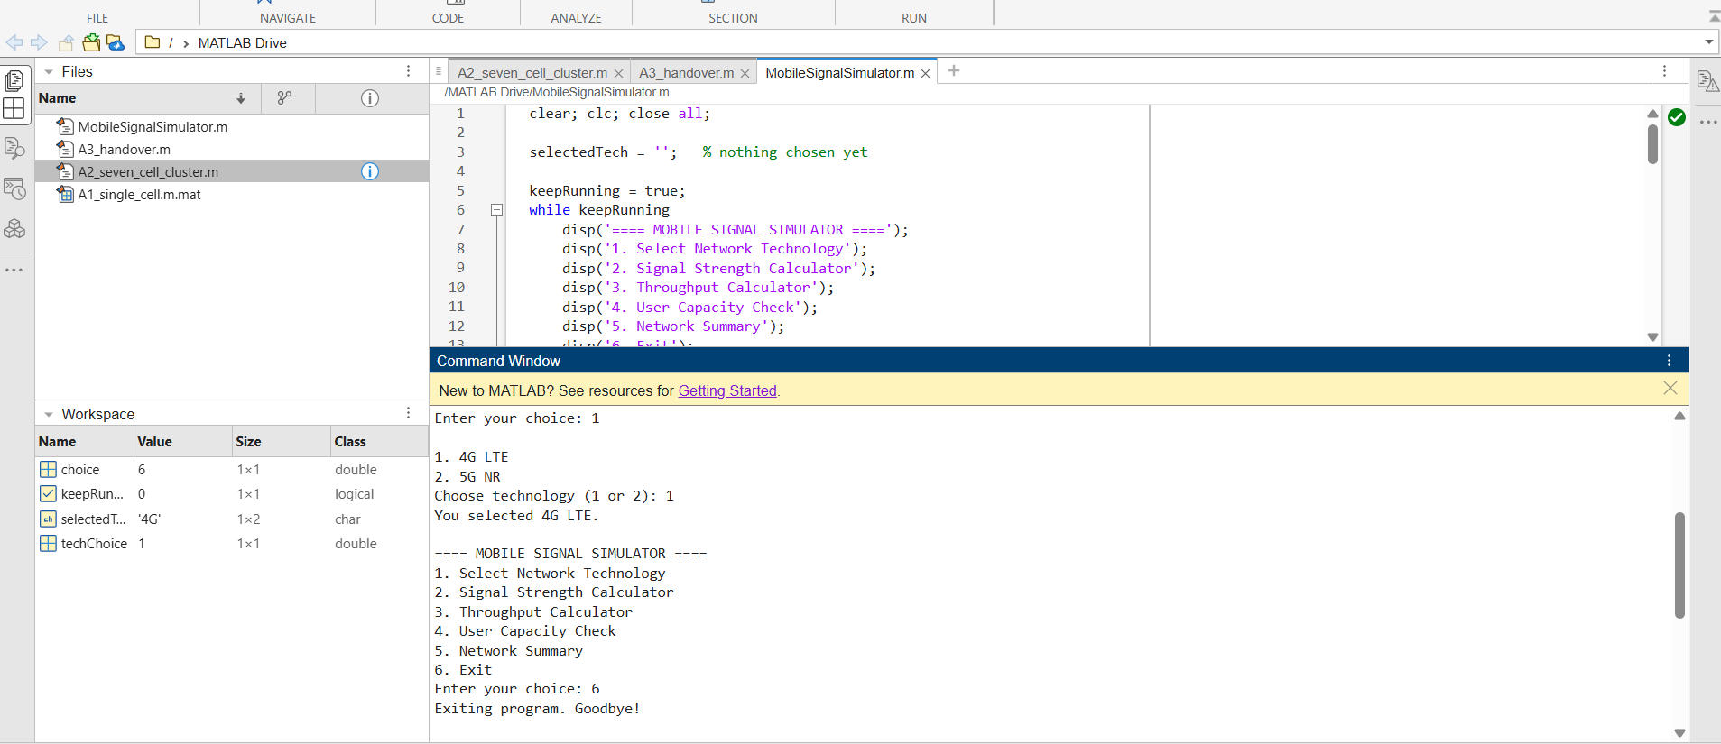
Figure 4: MATLAB output — main menu of the Mobile Signal Simulator, with 4G LTE selected

3.2 B2 — Signal Strength Calculator
The user enters the distance from the Base Station, in metres. The program calculates the signal strength as a percentage using a formula that depends on the technology selected earlier, then classifies the result into a quality label.
Technology | Signal Strength Formula
4G LTE | Signal (%) = 100 − (Distance ÷ 20)
5G NR | Signal (%) = 100 − (Distance ÷ 15)

Signal Range | Quality Label
80% – 100% | Excellent
60% – 79% | Good
40% – 59% | Fair
Below 40% | Poor

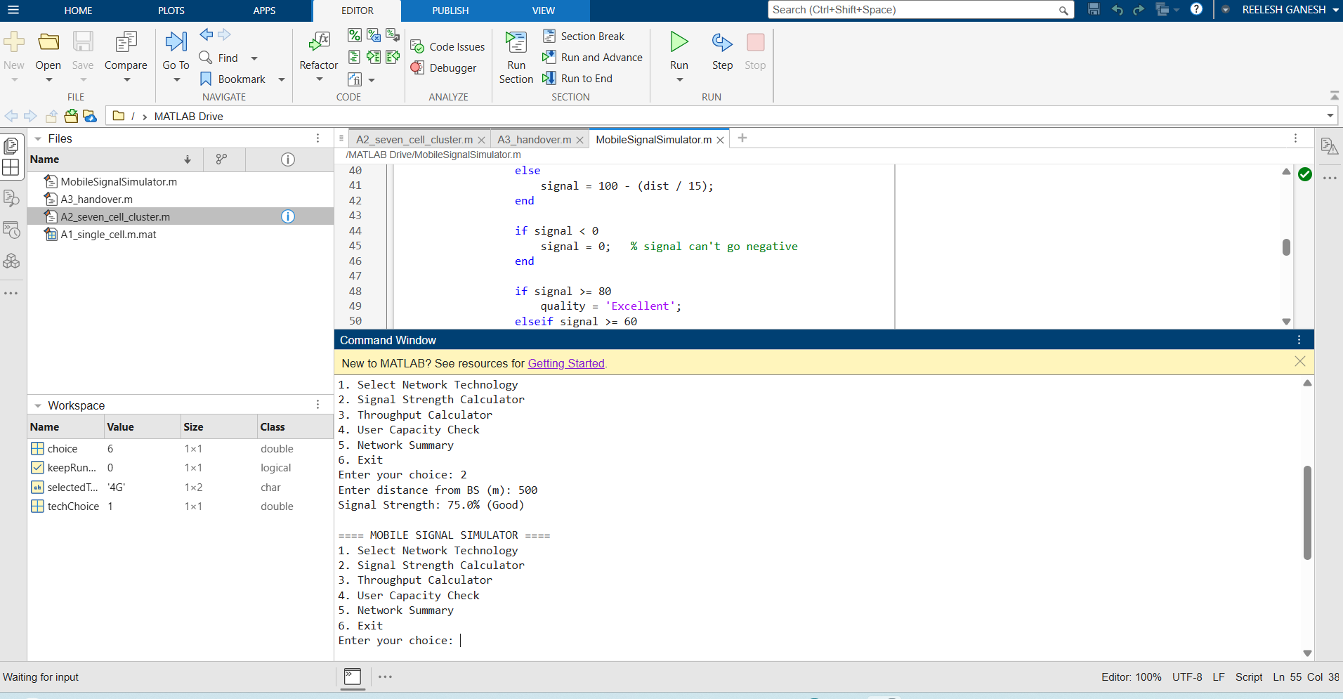
Figure 5: MATLAB output — Signal Strength Calculator; 500 m on a 4G network gives 75.0% (Good)

3.3 B3 — Throughput Calculator
The user enters a bandwidth value in MHz and a spectral efficiency value in bits per second per Hertz (bits/s/Hz). The program multiplies these two values together to estimate the network throughput in Megabits per second (Mbps), using the formula: Throughput (Mbps) = Bandwidth × Spectral Efficiency.
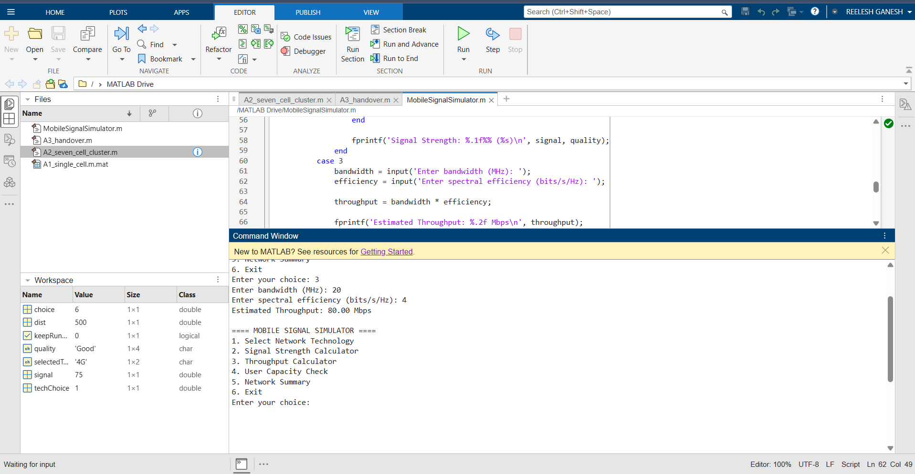
Figure 6: MATLAB output — Throughput Calculator; 20 MHz bandwidth and 4 bits/s/Hz gives 80.00 Mbps

3.4 B4 — User Capacity Check
The user enters the number of people currently connected to the cell. This is compared against the maximum capacity supported by the selected technology to calculate a utilisation percentage and a status label.
Technology | Maximum Capacity
4G LTE | 200 users
5G NR | 1000 users

Utilisation | Status
Below 80% | Normal
80% – 100% | Busy
Above 100% | Overloaded

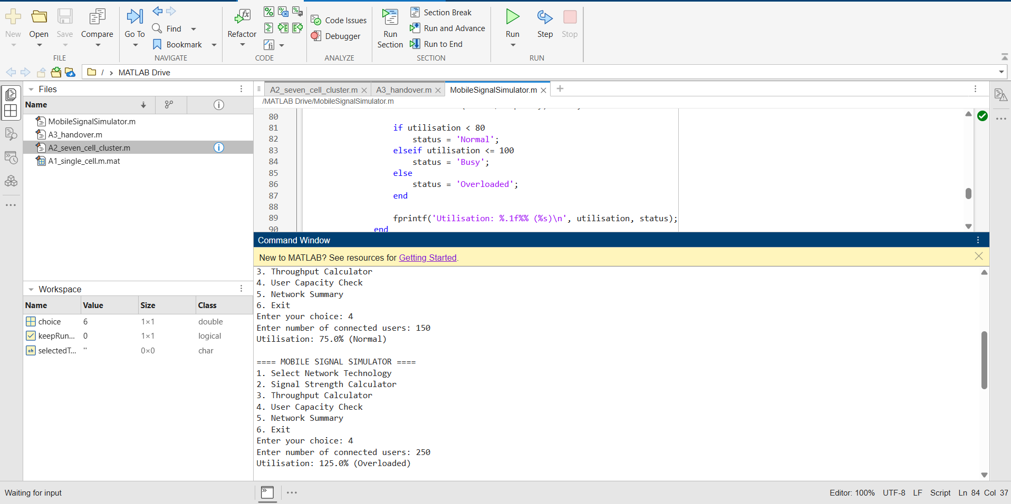
Figure 7: MATLAB output — User Capacity Check; 150 users gives Normal (75%), and 250 users gives Overloaded (125%) on a 4G network

3.5 B5 — Network Summary
The final menu option displays every result calculated so far in a single, clean summary: the selected technology, the signal strength and its quality label, the throughput, and the user capacity utilisation with its status. This gives the user a complete overview of the network's performance without needing to run each calculator separately again.
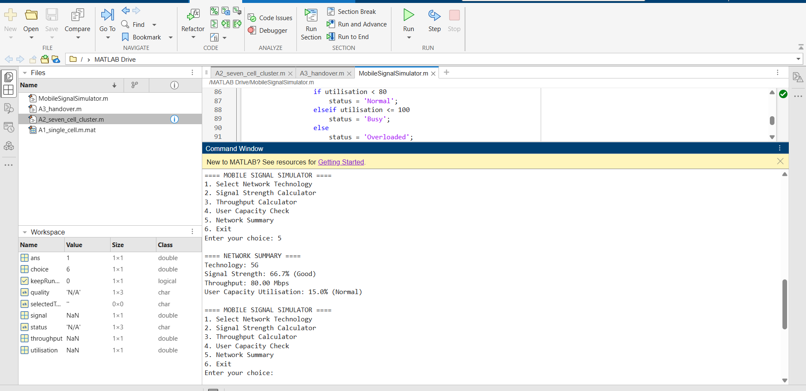
Figure 8: MATLAB output — Network Summary showing all results together for a 5G network

4. Part C — Graphs and Performance Analysis
Part C presents the same underlying formulas used in Part B, but displayed as graphs, which make it much easier to compare 4G and 5G performance at a glance. Three graphs were produced in a separate MATLAB script: a line plot, a bar chart, and a pie chart.

4.1 C1 — Signal Strength vs Distance
This line graph plots signal strength against distance from the Base Station, from 0 to 2000 metres, for both 4G and 5G, using vectors so that the formula is applied to the whole range of distances at once rather than one value at a time.
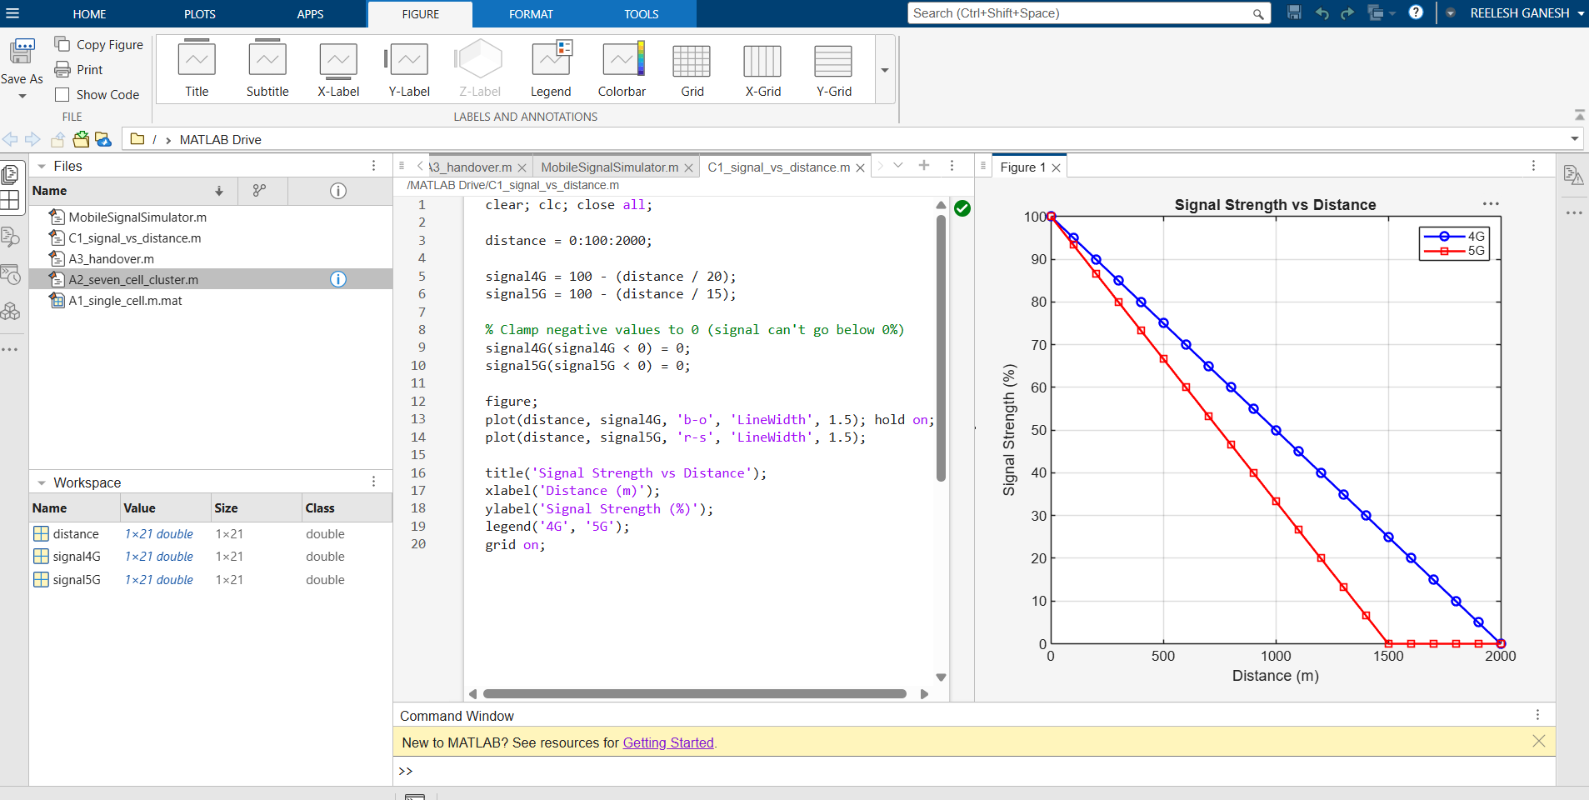
Figure 9: MATLAB output — Signal Strength vs Distance for 4G and 5G
The graph clearly shows that 5G signal strength (red line) decreases faster than 4G (blue line) as distance increases. This happens because 5G typically uses higher radio frequencies, which do not travel as far or pass through obstacles as easily as the lower frequencies traditionally used by 4G.

4.2 C2 — Throughput Comparison
This bar chart compares the estimated throughput of 4G LTE and 5G NR side by side, using example bandwidth and spectral efficiency values (4G: 20 MHz bandwidth, 20 bits/s/Hz efficiency; 5G: 100 MHz bandwidth, 8 bits/s/Hz efficiency).
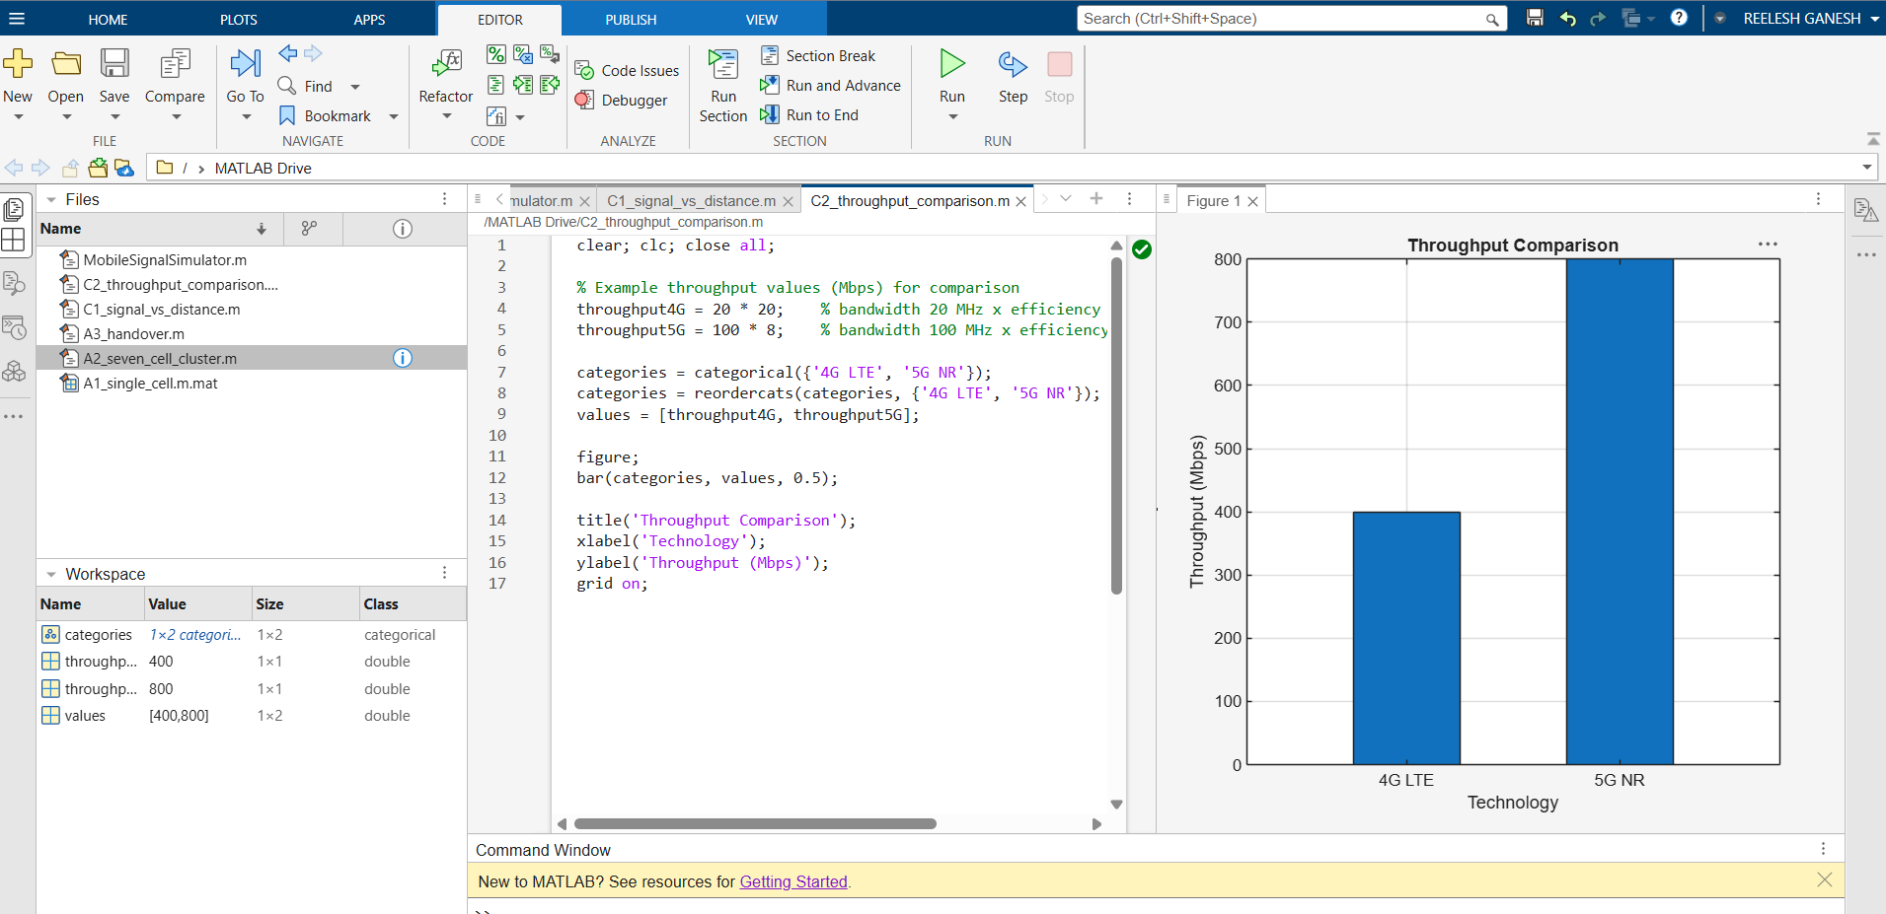
Figure 10: MATLAB output — throughput comparison between 4G LTE (400 Mbps) and 5G NR (800 Mbps)
The chart shows that 5G offers roughly double the throughput of 4G in this example, mainly because it uses a much wider bandwidth, even though its spectral efficiency value is lower.

4.3 C3 — User Capacity
This pie chart shows the proportion of user capacity offered by 4G (200 users) compared to 5G (1000 users).
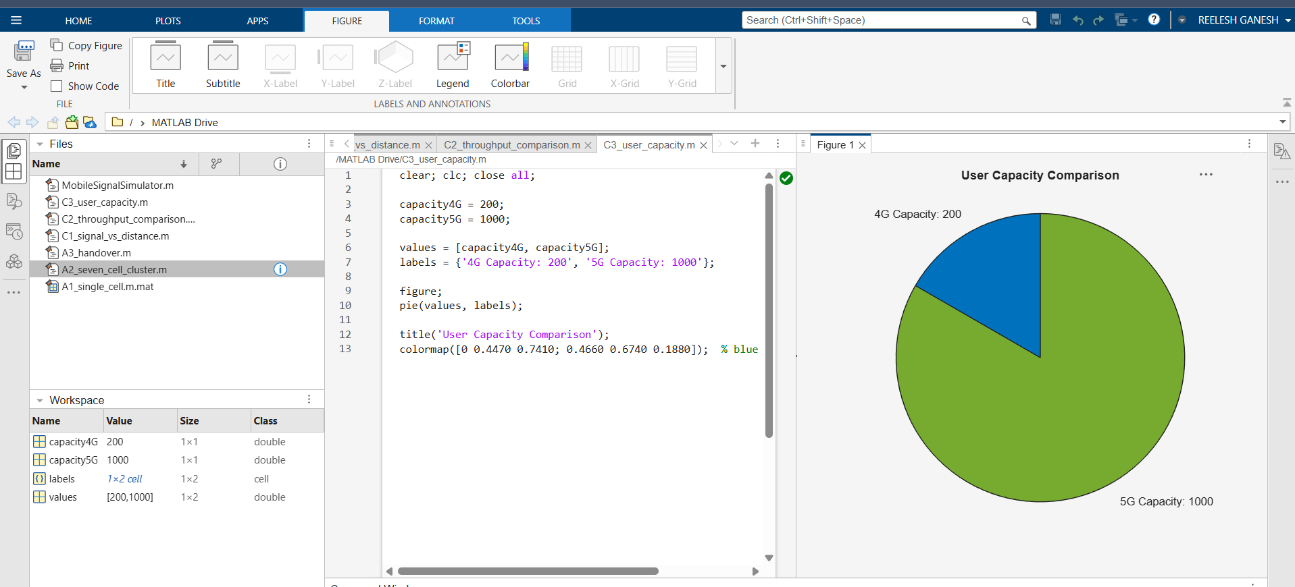
Figure 11: MATLAB output — user capacity comparison between 4G (200 users) and 5G (1000 users)
The chart shows that 5G can support far more connected users at the same time than 4G. This is one of the key real-world advantages of 5G technology, particularly in crowded areas such as stadiums, airports, and city centres.

5. Assumptions and Design Decisions
The assignment brief did not specify exact numeric values for every scenario, so the following reasonable assumptions were made while completing Parts A to C. These are noted here for transparency and can be adjusted if the module lecturer specifies different values.
- The handover point in A3 was placed at the midpoint between the two Base Stations, as a simple visual approximation. In a real network, the exact handover point depends on live signal strength measurements from both cells.
- The distance range used for the C1 graph (0 to 2000 metres) was chosen to clearly show both curves approaching 0% within the plotted range.
- The bandwidth and spectral efficiency values used in C2 (4G: 20 MHz / 20 bits/s/Hz; 5G: 100 MHz / 8 bits/s/Hz) were chosen as realistic example figures to produce throughput values close to those shown in the assignment brief (approximately 400 Mbps and 800 Mbps).
- The utilisation thresholds used in B4 (Normal below 80%, Busy 80–100%, Overloaded above 100%) were not given explicitly in the brief and were chosen as reasonable, commonly used thresholds for network load.

6. Remaining Work
The following parts of the assignment are being completed by the rest of the team and will be added to the final version of this report before submission:

6.1 Part D — Discussion (15 marks)
Written answers to five discussion questions comparing 4G and 5G performance, explaining why 5G requires more base stations, why handover is important, and suggesting applications that benefit from 5G.

6.2 Part E — Design Your Own Network (20 marks)
An extended MATLAB program that allows the user to configure a custom network (technology, cell radius, number of cells, number of users, frequency, bandwidth), generate the resulting cell layout, simulate a handover on the custom network, and display overall network statistics.

7. Conclusion
Through this assignment, our team learned how to use MATLAB to visualise core cellular network concepts such as cells, clusters, frequency reuse, and handover, and how to build an interactive, menu-driven program using loops, conditional statements, and custom functions. We also learned how to use MATLAB's plotting tools, including line plots, bar charts, and pie charts, to compare the performance of 4G and 5G networks in a way that is easy to understand at a glance.
Overall, completing Parts A, B, and C gave us a clearer, hands-on understanding of how modern mobile networks are planned and how 5G improves on 4G in terms of throughput and user capacity, while also involving trade-offs such as a shorter effective signal range and the need for a greater number of base stations to cover the same area.

8. Marking Scheme Reference
The table below summarises the official mark allocation for this assignment, as provided in the assignment brief, for reference.
Part | Description — Marks
Part A | Network Visualisation Using MATLAB — 25 marks
Part B | Mobile Signal Simulator — 40 marks
Part C | Graphs and Performance Analysis — 20 marks
Part D | Discussion — 15 marks
Part E | Design Your Own Network Using MATLAB — 20 marks
Total | 100 marks

